**IoT Based Safety Gadget for Child Safety Monitoring &      Notification**

1. **INTRODUCTION**

          1.1 Project Overview

   The internet of things (IoT) refers to the set of devices and system that stay interconnected with real-world sensor and to the internet. During years’ Child safety is under threat and it is very important to provide a technology-based solution which will help them under panic situations and monitor them using a smart gadget.The proposed system is equipped with GSM and GPS modules for sending and receiving call and SMS between safety gadget and parental phone, the proposed system also consists of Wi-Fi module used to implement IoT and send all the monitoring parameters to the cloud for android app monitoring on parental phone. Android application can be used to track the current location of safety gadget using its location coordinates on parental phone android app and also via SMS request from parent phone to safety gadget. Panic alert system is used during panic situations and automatic SMS alert and phone call is triggered from safety gadget to the parental phone seeking for help and also monitored for plug and unplug from hand, as soon the gadget is unplugged from hand a SMS is triggered to parental phone and the alert parameter is also updated to the cloud.

      1.2 **Purpose**

  Heart-beats, temperature is monitored and the values are updated to cloud continuously for parent app monitoring. Boundary monitoring system is implemented on safety gadget with the help of BEACON technology, as soon as the safety gadget moves far away from the binding gadget an alert is provided to parent on binding gadget. the system is used to monitor the health parameters and also used for location tracking during necessary situations in safety concern.

          2**. LITERATURE SURVEY**

      2.2 References

            [1] Authors: M Nandini Priyanka, S Murugan, K. N. H. Srinivas, T. D. S. Sarveswararao, E. Kusuma Kumari. Title: Smart IoT Device for Child Safety and Tracking. Published in: 2019 IEEE. The system is developed using Link-It ONE board programmed in embedded C and interfaced with temperature, heartbeat, touch sensors and also GPS, GSM & digital camera modules. The novelty of the work is that the system automatically alerts the parent/caretaker by sending SMS, when immediate attention is required for the child during emergency. Merits: The parameters such as touch, temperature & heartbeat of the child are used for parametric analysis and results are plotted for the same. Demerits: To implement the IoT device which ensures the complete solution for child safety problems. [2] Authors: Akash Moodbidri, Hamid Shahnasser Title: Child safety wearable device. Published in: 2017 IEEE. The purpose of this device is to help the parents to locate their children with ease. At the moment there are many wearable’s in the market which helps to track the daily activity of children and also helps to find the child using Wi-Fi and Bluetooth services present on the device. Merits: This wearable over other wearable is that it can be used in any phone and it is not necessary that an expensive smartphone is required and doesn’t want to be very tech savvy individual to operate. Demerits: As, this device’s battery gives short life-time. High power efficient model will have to be used which can be capable of giving the battery life for a longer time.[3] Authors: Aditi Gupta, Vibhor Harit. Published in: 2016 IEEE. Title: Child Safety & Tracking Management System by using GPS. This paper proposed a model for child safety through smart phones that provides the option to track the location of their children as well as in case of emergency children is able to send a quick message and its current location via Short Message services. Merits: The advantages of smart phones which offers rich features like Google maps, GPS, SMS etc. Demerits: This system is unable to sense human behavior of child.[4] Authors: Dheeraj Sunehera, Pottabhatini Laxmi Priya. Title: Children Location Monitoring on Google Maps Using GPS and GSM. Published in: 2016 IEEE. This paper provides an Android based solution for the parents to track their children in real time. Different devices are connected with a single device through channels of internet. The concerned device is connected to server via internet. The device can be used by parents to track their children in real time or for women safety. The proposed solution takes the location services provided by GSM module. It allows the parents to get their child’s current-location via SMS. Merits: A child tracking system using android terminal and hoc networks. Demerits: This device cannot be used in rural areas.

**2.3 Problem Statement Definition**

Create a problem statement to understand your customer's point of view. The Customer Problem Statement template helps you focus on what matters to create experiences people will love. A well-articulated customer problem statement allows you and your team to find the ideal solution for the challenges your customers face. Throughout the process, you’ll also be able to empathize with your customers, which helps you better understand how they perceive your product or service.

3. **IDEATION & PROPOSED SOLUTION**

     3.1 Empathy Map Canvas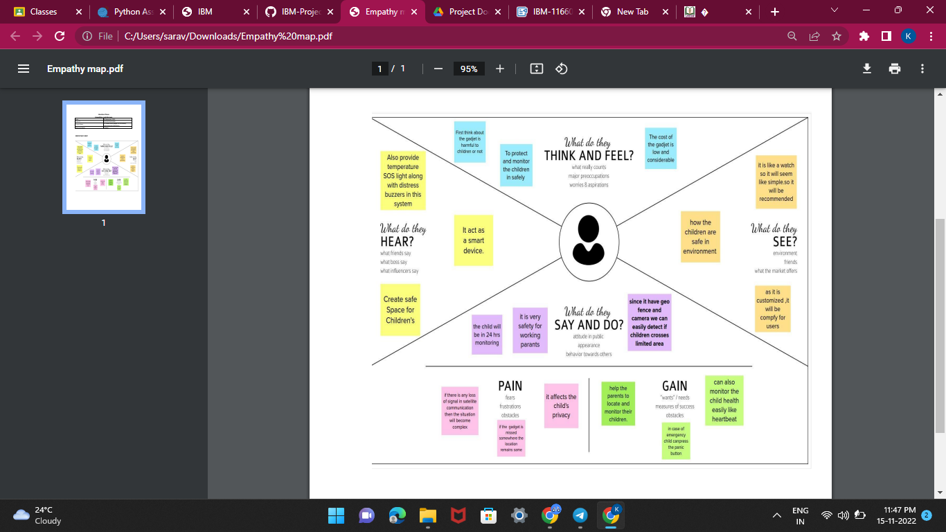

**3.2 Ideation & Brainstorming**

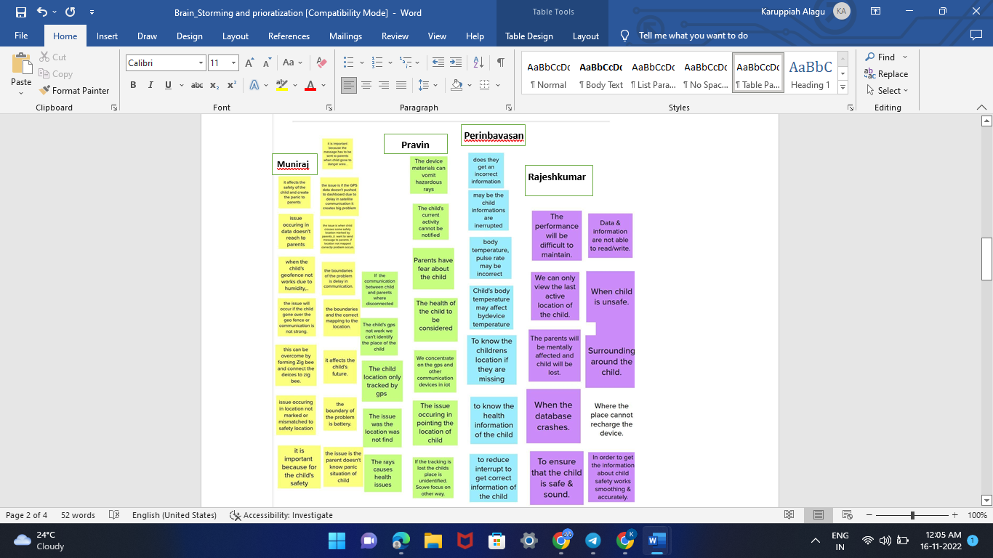

     3.3 **Proposed Solution**

      The block diagram of the proposed child safety device. It consists of inbuilt Wi-Fi, GSM, GPS and Bluetooth modules. The link it one board is similar to the Arduino board and it is termed as all-in-one prototyping board for safety and IoT devices. The link it one is a robust development board for the hardware and also used for industrial applications. Different components such as temperature sensor, heartbeat sensor, panic button, contact switch are connected to the link it ONE board along with built in GSM, GPS modules. Safety gadget consists of BEACON and BLE packet is transmitted through it, this packet is received by binding gadget which has BLE receiver module, the packet usually contains information such as identification number, signal strength etc. Temperature is one of the most commonly measured variables. For measuring body temperature of the child DS18B20 temperature sensor is used. The heartbeat sensor is used in the proposed system for measuring the pulse rate. There is a heartbeat/pulse sensor which is combined to simple optical heart rate sensor with amplification and nullification circuitry making it is fast and easy to get reliable pulse reading. The GSM/GPRS block is activated with a SIM card on the board. They mainly differ based on bandwidth and RF carrier frequency.

GSM network consists of mobile station, base station subsystem network and operation subsystem. The GPS module is provided for identifying the location of the child. GPS module receives the signals from satellites. The latitude and longitude of the location can be identified by the GPS module. The device sends the monitored parameters data such as temperature and pulse rate to cloud. If any abnormalities occurs in temperature or pulse rate readings, a SMS and call triggers to the parent/caretaker mobile phone immediately and also updated to the mobile app only for the registries mobile no. We can use mobile application, cloud and database as the back end of storing and retrieving information and also a device for monitoring.

Software Specification The Arduino Software (IDE) which is an open-source and makes it easy to write the code as well as to upload in to the board. It runs on the Linux, Mac, IOS and Windows. The programs are written in Java, based on the Processing and other open-source software. This software makes the interfacing with Arduino-Uno much more reliable. The primary reason for using the GS shield as the mode of communication over Wi-Fi and Bluetooth was that this gadget was aimed at being accessible to any smartphone user.

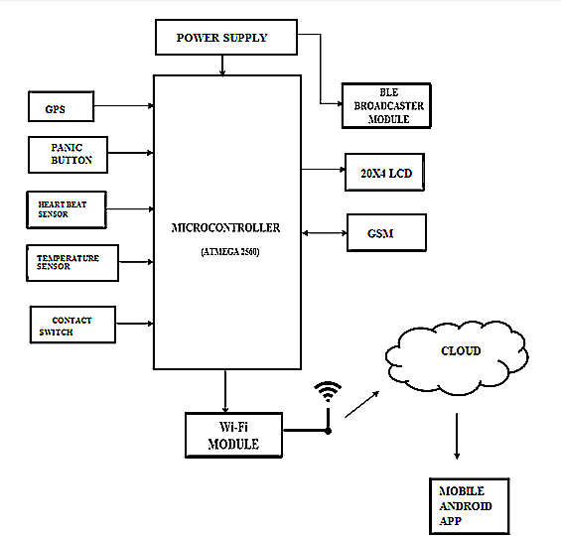

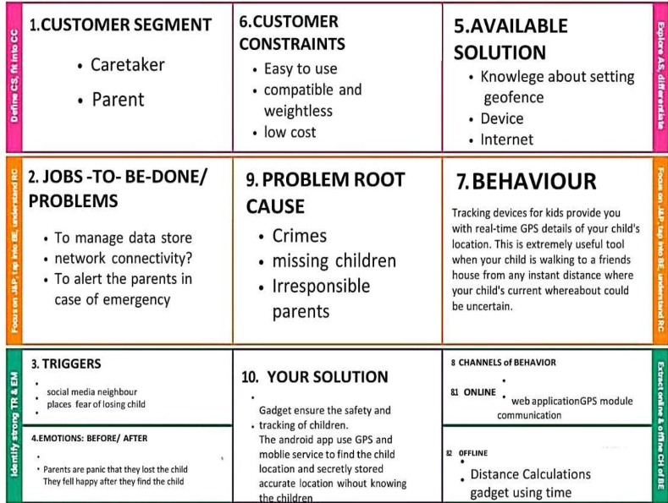

4. **REQUIREMENT ANALYSIS**

**4.1 Functional requirement**

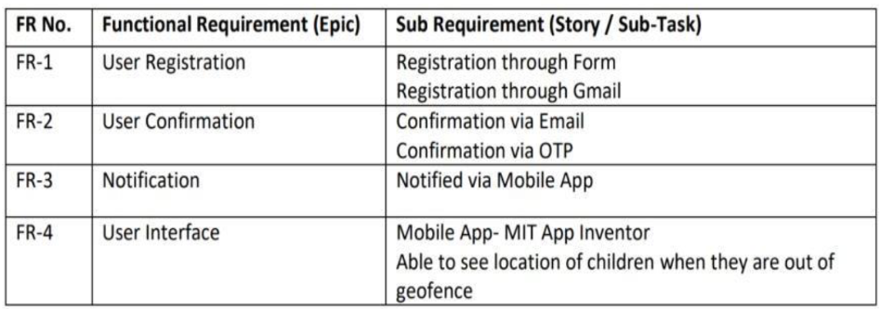

**4.2 Non-Functional requirements**

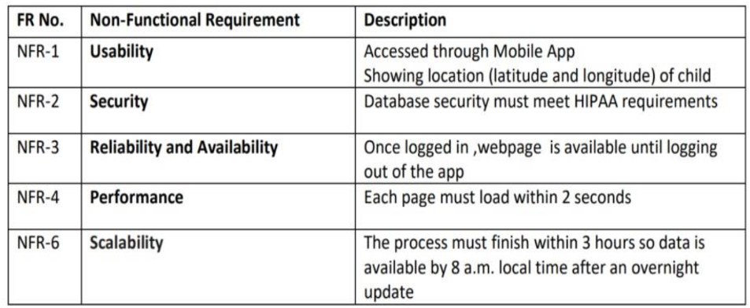

**5**. **PROJECT DESIGN**

**5.1 Data Flow Diagrams**

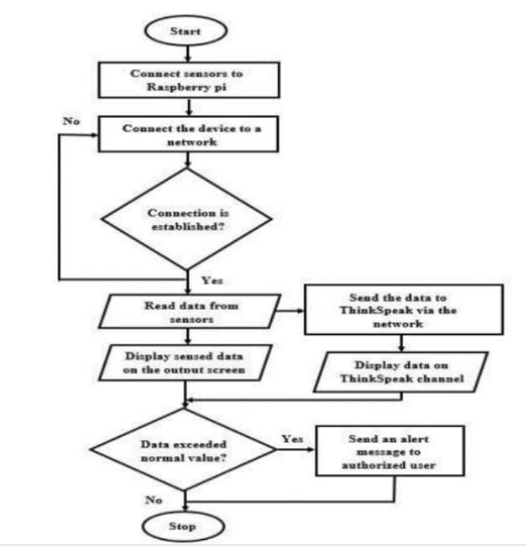

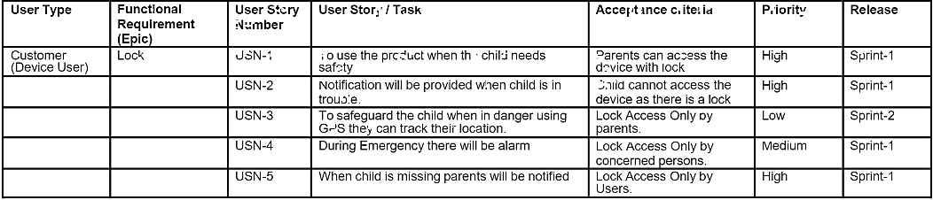

   6. **PROJECT PLANNING & SCHEDULING**

     6.1 Sprint Planning & Estimation

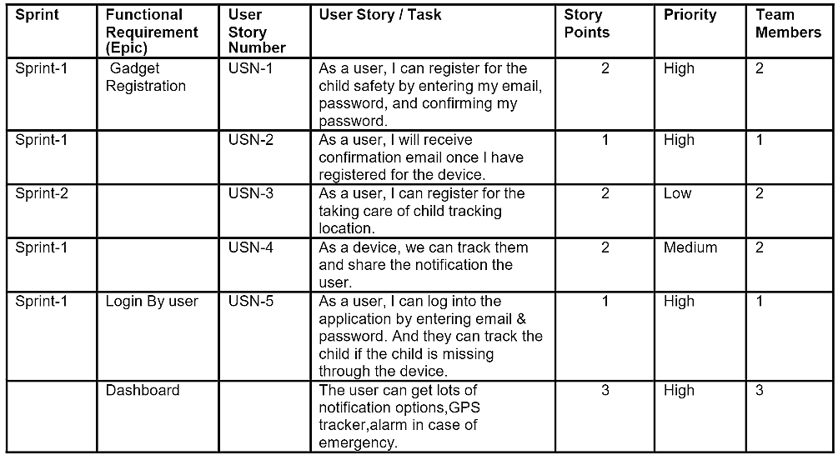

**6.2 Sprint Delivery Schedule**

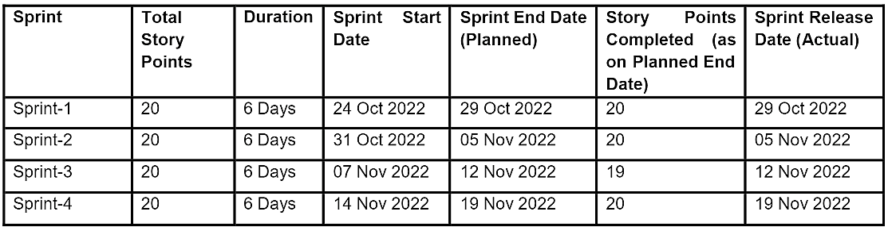

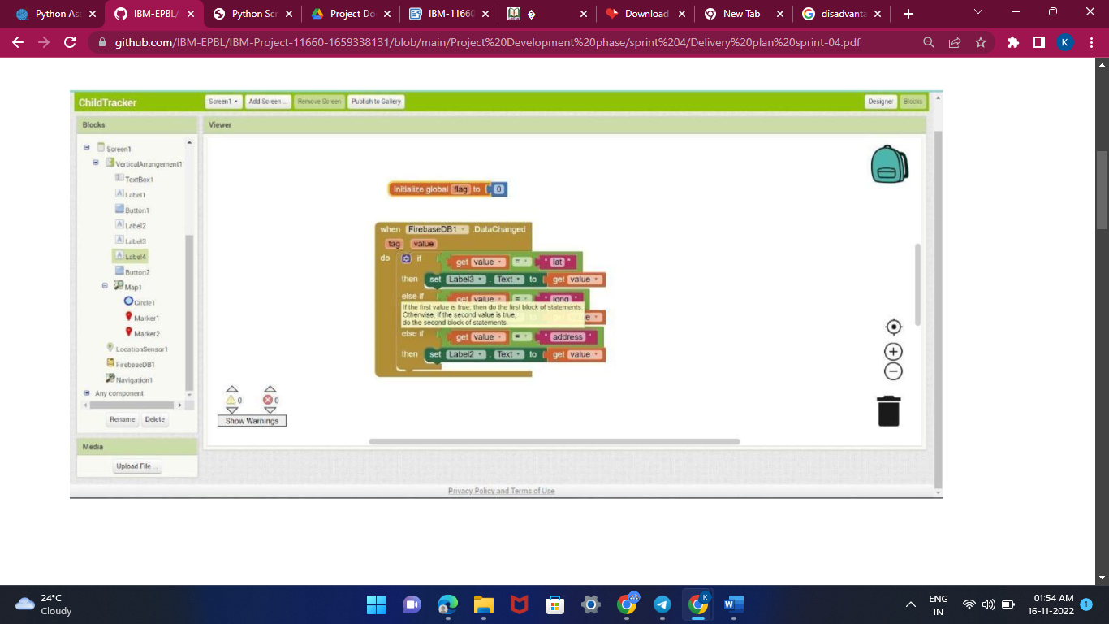

7. **CODING & SOLUTIONING (Explain the features added in the project along with code)**

    import json

   import wiotp.sdk.device

   import time

  myconfig = {

       "idebtity":  {

          "orgId": "hj5fmy",

          "typeId": "NodeMCU",

          "deviceId": "12345678"

  },

    "auth": {

"token": "12345678"

               }

}

client = wiotp.sdk.device.Deviceclient(config=myconfig, logHandlers=None)

client.connect()

while True:

                name= "Smartbridge"

#in area location

#latitude=17.4225176

#longitude=78.5458842

#out area location

latitude=17.4219272

longitude=78.5488783

myData={'name': name, 'lat': latitude,'lon': longitude} client.publishEvent(eventId="status",msgformat="json",

data=mydata, qos=0, onpublish=None)

print("Data published to IBM IOT platform :",myData)

time.sleep(5)

client.disconnect()

8. **TESTING**

    8.1 Test Cases

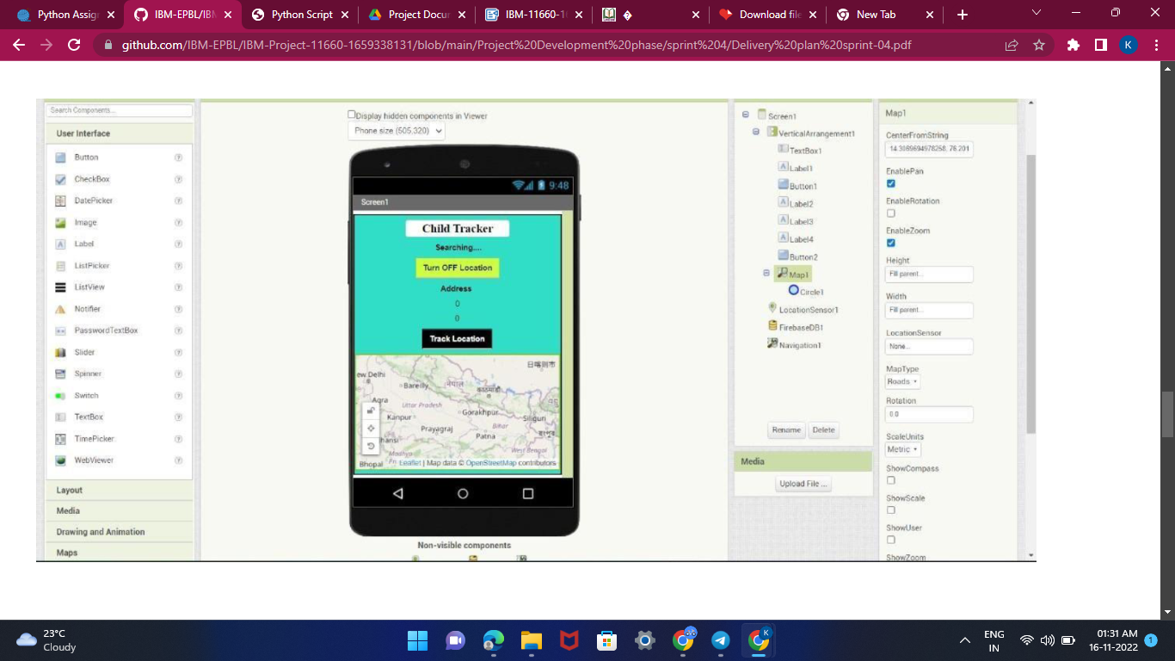

    8.2 User Acceptance Testing

9. **RESULTS**

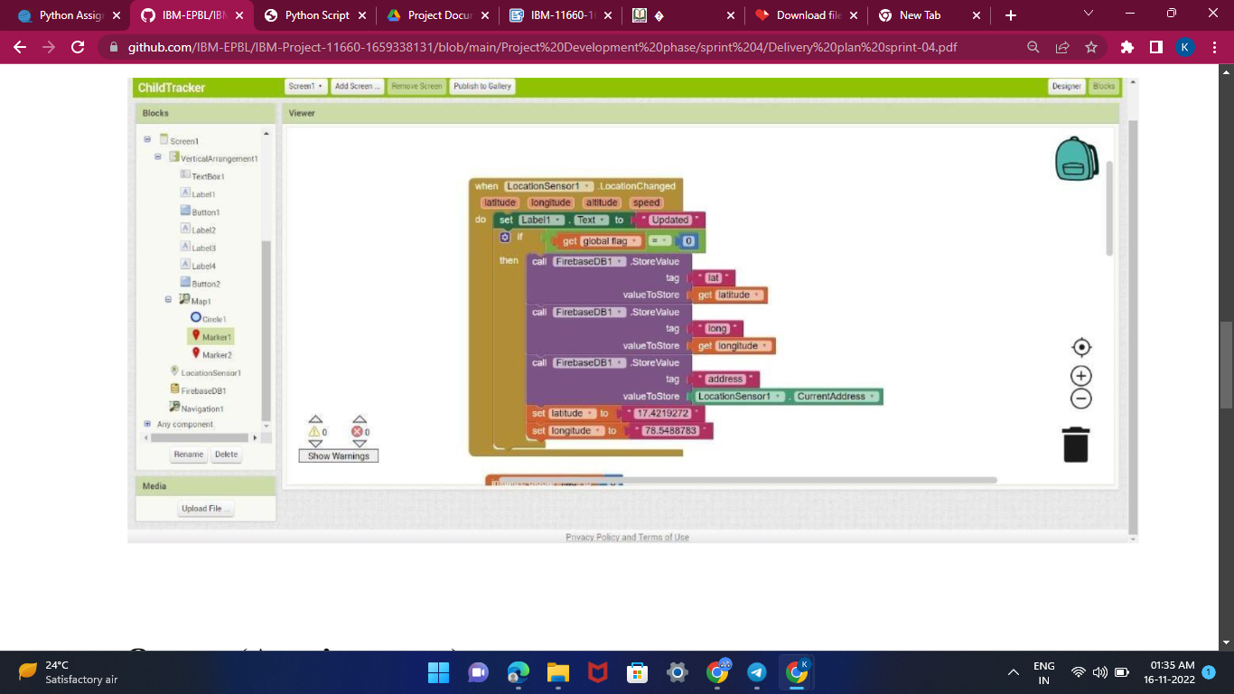

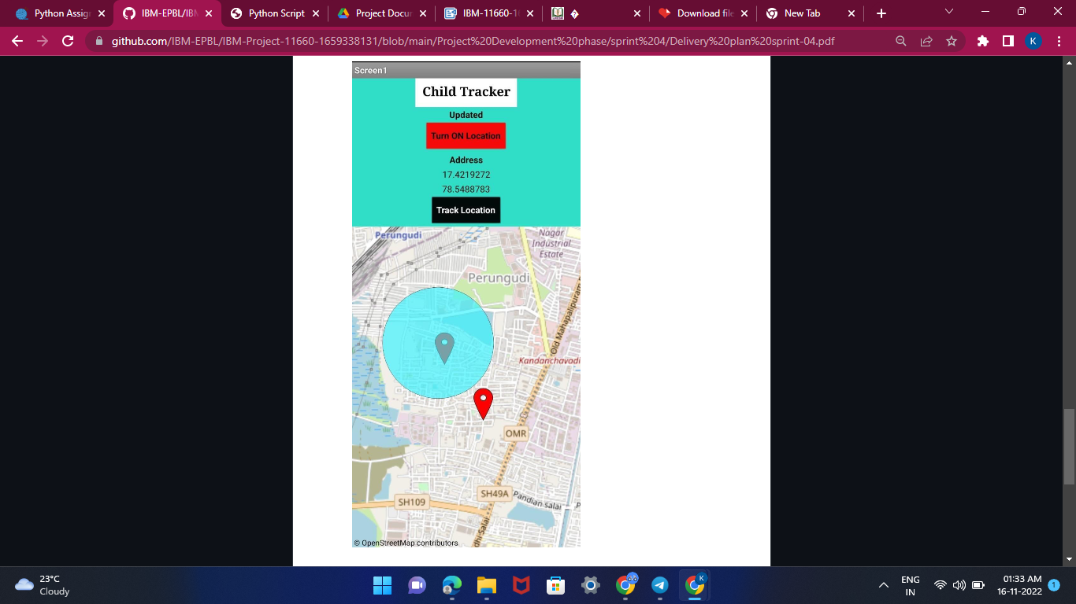

10. **ADVANTAGES & DISADVANTAGES**

It assists parents to monitor their children remotely. In case situations happen, notifications will be sent to parents so that actions can be taken. Through this, child safety can be ensured and crime rate will be reduced.

**Disadvantage:**

This device cannot be used in rural areas. Figure 1 shows the block diagram of the proposed child safety device. It consists of inbuilt Wi-Fi, GSM, GPS and Bluetooth modules.

11. **CONCLUSION**

This research demonstrates Smart IoT device for child safety and tracking, to help the parents to locate and monitor their children. If any abnormal readings are detected by the sensor, then an SMS and phone call is triggered to the parents mobile. Also, updated to the parental app through the cloud. The system is equipped with GSM and GPS modules for sending and receiving call, SMS between safety gadget and parental phone. The system also consists of Wi-Fi module used to implement IoT and send all the monitored parameters to the cloud for android app monitoring on parental phone. Panic alert system is used during panic situations alerts are sent to the parental phone, seeking for help also the alert parameters are updated to the cloud. Boundary monitoring system is implemented on safety gadget with the help of BEACON technology, as soon as the safety gadget moves far away from the BLE listener gadget an alert is provided to itself.

**Source Code**

from http import client

import json

import wiotp.sdk.device

import time

myConfig = {

    "identify":{

        "orgId":"hj5fmy",

        "typeId":"NodeMCU",

        "deviceId":"12345678"

    },

    "auth":{

        "token":"12345678"

    }

}

client = wiotp.sdk.device.DeviceClient(config=myConfig, logHandlers=None)

client.connect()

while True:

    name= "Smartbridge"

    #in area location

    #latitude=17.4225176

    #longitude 78.5458842

    #out area location

    latitude=17.4219272

    longitude=78.5488783

    myData={'name': name, 'lat': latitude, 'lon': longitude}

    client.publishEvent(eventId="status", msgFormat="json", data=myData, qos-0, onPublish=None)

    print("Data published to IBM IOT platfrom: ",myData)

    time.sleep(5)

client.disconnect().

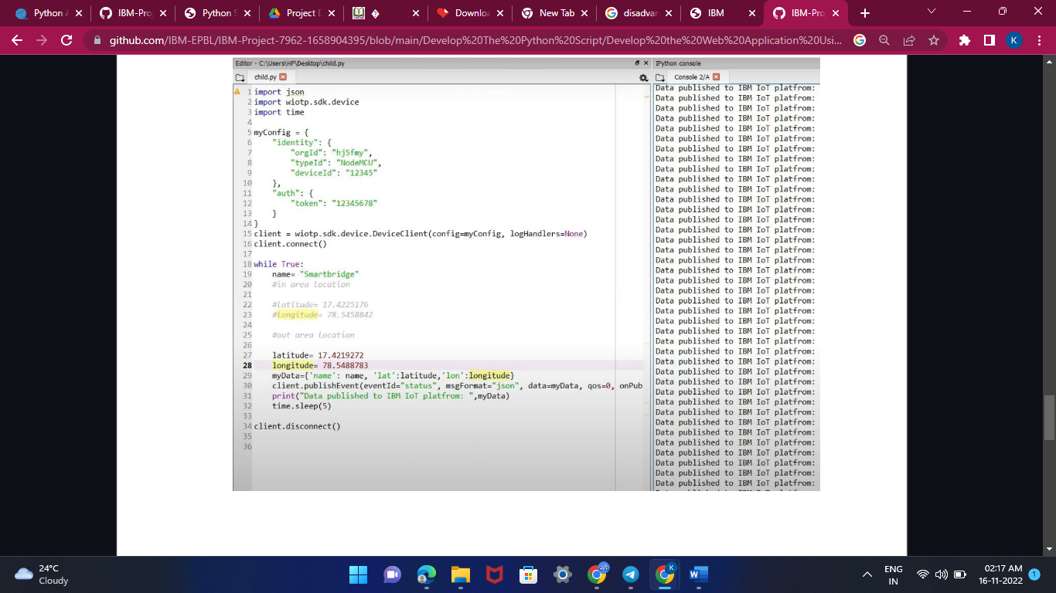

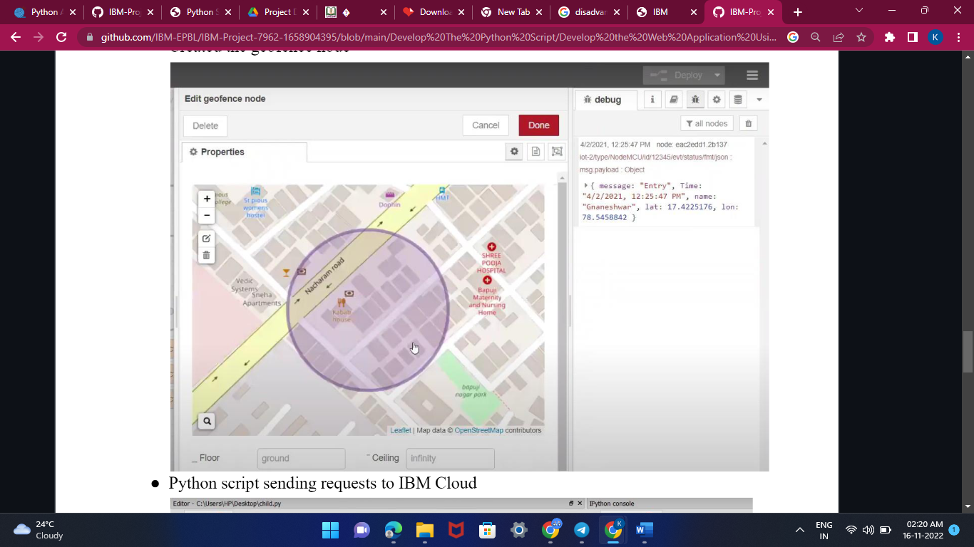

GitHub & Project Demo Link

<https://github.com/IBM-EPBL/IBM-Project-11660-1659338131>